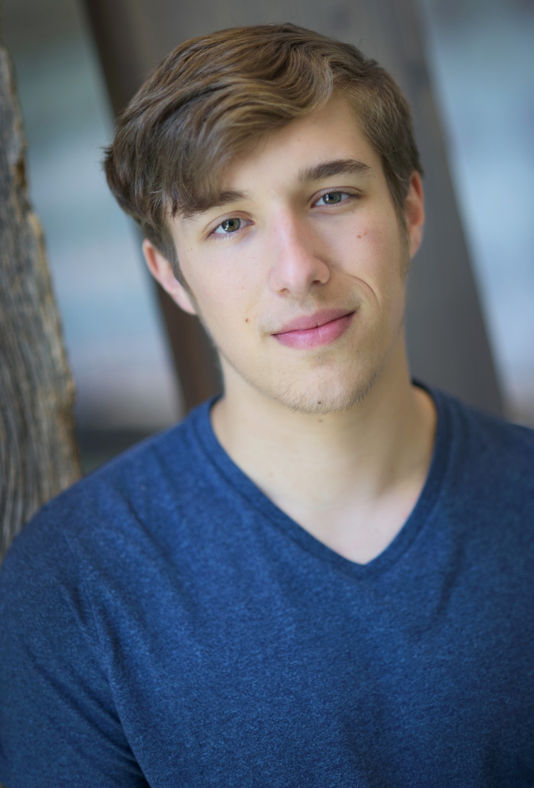
RAY BARBER

Height: 5’10 Hair Color: Light Brown Eyes: Green Vocal Range: Bass/Bari
Phone: (832)707-8857 Email: raybarber2002@gmail.com
Website: raybarbertheatre.com
 | STAGE ACTING
Lucky Stiff | Man 1 U/S (performed) | Florida Studio Theatre
Deck the Halls | Jangle | Florida Studio Theatre
Snow White (Two Actor Tour) | Performer | Florida Studio Theatre
TEXAS! The Outdoor Musical | Ezra, Featured Singer | Pioneer Amphitheater
A Funny Thing… Forum | Pseudolus | WT Theatre
Alice By Heart | Dr. Butridge, Chorus Master | WT Theatre
Once Upon A Mattress | Prince Dauntless | WT Theatre
Into the Woods | Rapunzel’s Prince | Amarillo College
The Spongebob Musical | Perch Perkins, Plankton U/S | WT Theatre
Sweeney Todd | Ensemble, Sweeney U/S | WT Theatre
 | TRAINING
Choir | Oak Ridge HS, WT Theatre | JR Smith, Maryn West, Thomas Kang, Dr. Sean Pullen
Vocal Lessons | Oak Ridge HS, West Texas A&M University, Open Jar Institute | Lindsay Bowden, Shannon Burr, Dr. Robert Hansen
Improv | Oak Ridge HS, WT Theatre, Open Jar Institute, Florida Studio Theatre | Val Prahl, Stephen Crandall, Echo Sibley, Jake Swain, Sarah Durham, Dellan Short
Dance (tap, jazz, ballet, hip hop, modern, MT) | NHPA, Oak Ridge HS, WT Theatre, Open Jar Institute | Crystal Bertrand, Sandra Miller, Stacy Clay, Correy West, Timothy Hughes, James Gray
 | SKILLS
Skilled in various accents, dialects, and character voices. Able to cartwheel, forward roll, back shoulder roll, pratfall.

Can grow facial hair, but only to look like Shaggy from Scooby Doo.

